**LEBANESE AMERICAN UNIVERSITY**

**USAID – HIGHER EDUCATION SCHOLARSHIP PROGRAM**

**HES - Volunteering Program Verification Form**

This form is to be used to document volunteering hours. If a student volunteers for multiple organizations, a separate form must be used for each organization. **This form must be turned in by the 28th of each month, the latest.**

I certify that the scholar Sana Abou Zour completed a total of 5 hours of service at InnovaThrive.

The hours were completed hours as per the below:

Hours # 0 (date) _2/12 – 6/12_ (initials of supervisor) __A.K.___

Hours # 0 (date) _9/12 – 13/12_ (initials of supervisor) __A.K.___

Hours # 5 date) _16/12 – 20/12 (initials of supervisor) __A.K.___

Hours # 0 date) _23/12 - 27/12 (initials of supervisor) __A.K.___

Brief description of the activities the scholar performed or participated in:

I conducted a research bundle focused on AI in Personalizing Mental Health Treatments, exploring how artificial intelligence can tailor mental health solutions to individual needs for more effective outcomes.

Written feedback about the scholar’s performance:

Sana showcased strong research and analytical skills by exploring AI’s potential in personalizing mental health treatments for improved outcomes.

Please rate the overall performance of the scholar at your organization:

|  |  |  |  |
| --- | --- | --- | --- |
|  | Mastery (5) | Proficient (3) | Emerging (1) |
| **Problem solver** | X |  |  |
| **Engaged & Committed** | X |  |  |
| **Open-minded & multicultural** | X |  |  |

Signature

& stamp

__________________________

_

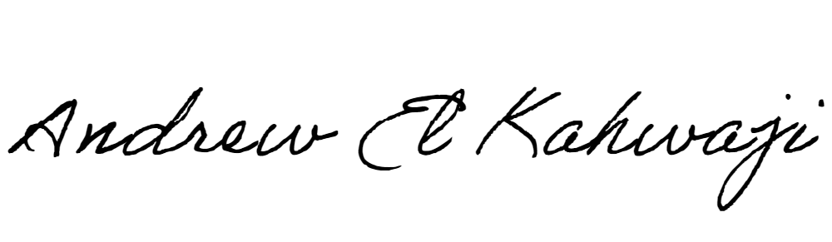

Printed Name _Andrew El Kahwaji_

Date __26/12/2024___

Email __andrew.lifesculptor.coo@gmail.com __

Phone __+961 71 914 378__